NAJUA Western Region Proud to Be Part of the 2012 Chinese New Year Festival
Jiancai Li
1/28/ 2012
NAJUA Western Region is proud to have taken part in a colorful Chinese New Year Celebration at the Arvada Center for the Arts and Humanities in Colorado on Saturday, January 21, 2012. This was the biggest and most exciting Chinese New Year event in Colorado, with enthusiastic support from Colorado business community and local governments. The event featured an extensive entertainment program with an Asian cultural fair showcasing authentic Chinese arts, crafts, and foods, as well as delightful shows featuring local and international Asian entertainers performing dance, folk songs, magic, acrobatics, and martial arts.
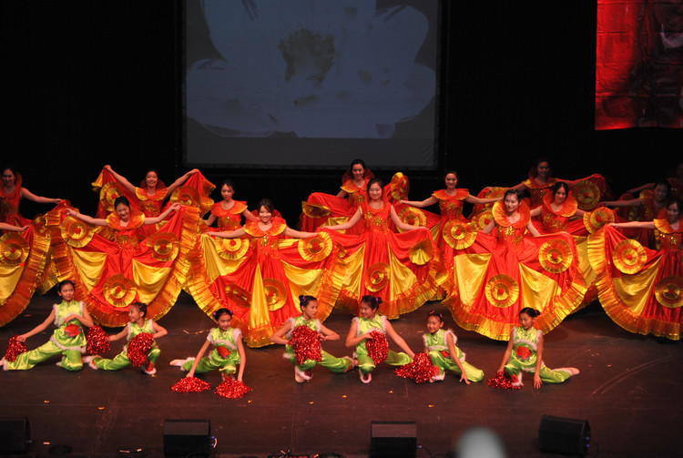
Opening Dance

With the financial support from NAJUA, we were able to contribute a dozen of show tickets to our American and Asian friends to come and celebrate the Year of the Dragon with fellow Coloradans. Our friends truly appreciated NAJUA for its generous support, making their day of Chinese cultural experience most enjoyable and memorable. NAJUA is proud to be involved in wonderful events like this, which encourages our young people to become better citizens and better friends to one another.
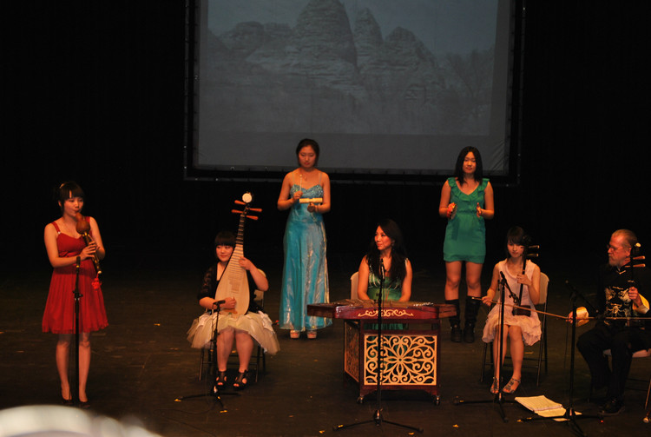
Chinese Traditional Instruments

NAJAU continues to play an integral role in enriching the cultural diversity, friendship and professional growth. As the Year of the Dragon will be a decisive year for opportunities, we wish all have a happy, healthy, and prosperous 2012.

